

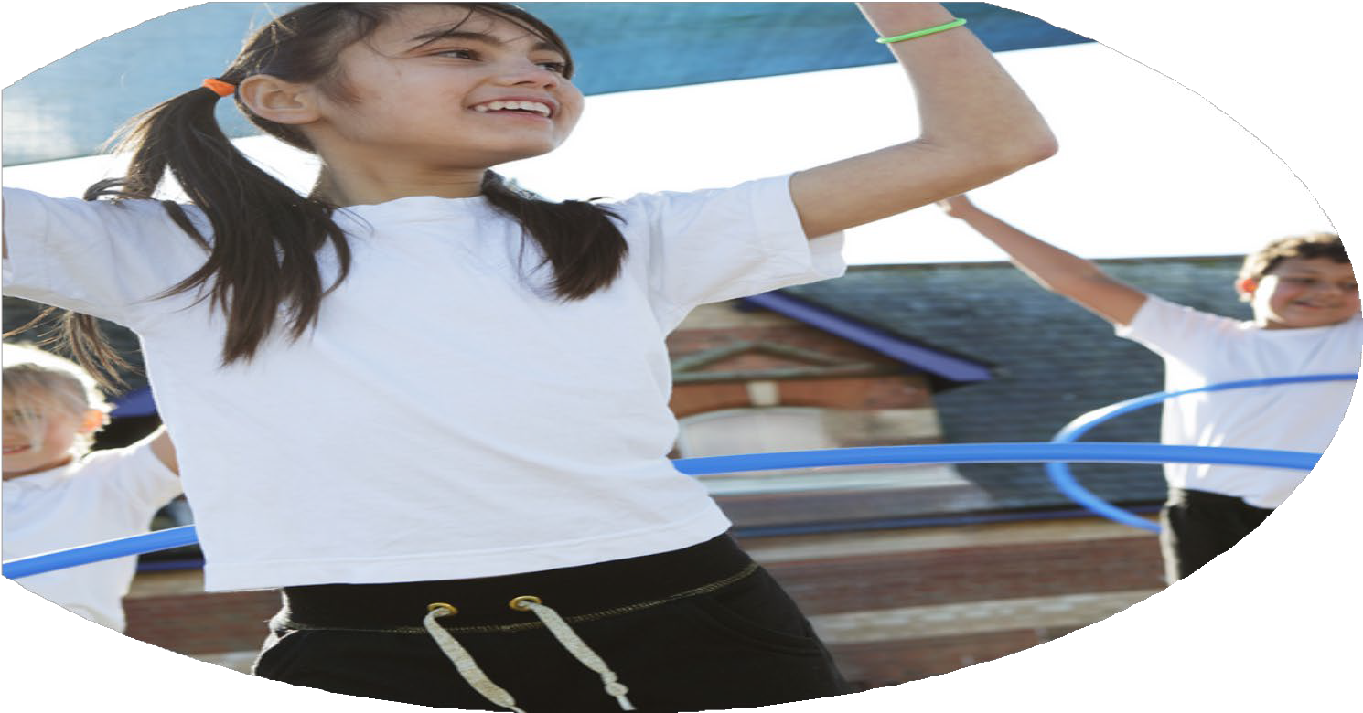
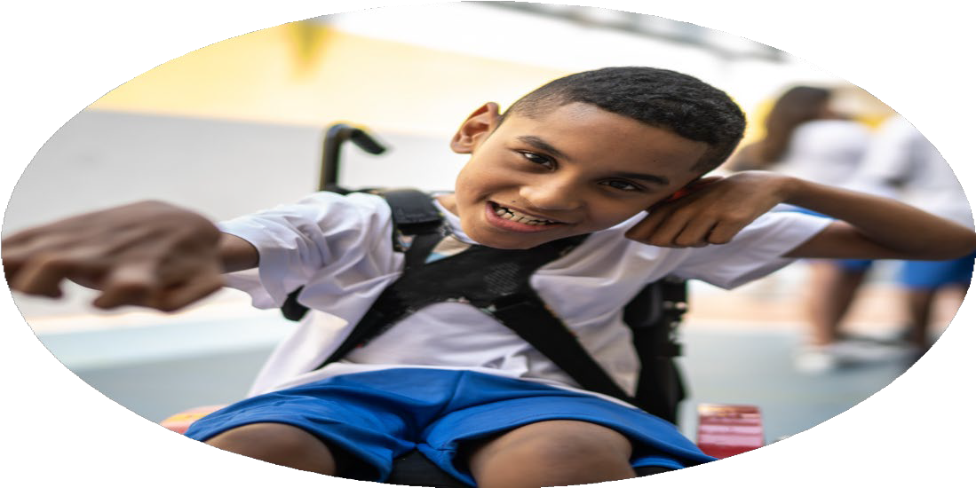
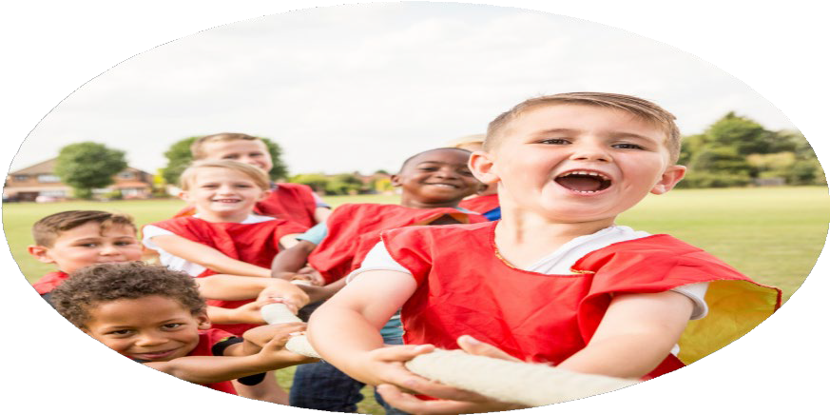



PE Funding

Evaluation Form

Commissioned by

Created by

Images courtesy of Youth Sport Trust

PE Funding Evaluation Form

It is intended that this template should be used as preparation for the completion of the statutory digital reporting tool being introduced this academic year. You can upload data (including swimming) from this template onto this platform once it becomes accessible.
Before you decide how you are going to use the funding for this academic year you should reflect and evaluate the impact of your use of the funding in 2023/24.
All spending of the funding must conform with the terms outlined in the Conditions of Grant document. The template is a working document that you can amend/update during the year.
Based on your evaluation of last year’s funding you should decide what you intend to do this academic year, how you will do it, and what impact you expect it to have.

It is important that the funding is used effectively and based on your school’s needs.
You must use the funding to make additional and sustainable improvements to the PE and sport in your school. You must develop and add to the PESSPA activities that your school already offers.

Summative digital reporting from June 2025 will continue to include swimming and water safety information therefore funding can be used to provide top-up lessons where necessary to ensure pupils meet national curriculum swimming requirements.

What went well? | How do you know? | What didn’t go well? | How do you know?
Children engage in a range of inter-school activities, hosted by School Games.  GHA’s PE/Sports offer is endorsed by national accreditation. GHA children take part in appropriately adapted PE sessions, regular movement breaks and sensory needs are met. | Active participation in a variety of external events – swimming, tennis, panathlon, kin ball.  Bronze School Games Mark  AfPE Award | Meeting National Curriculum Requirements for swimming and water safety.Despite additional swimming lessons being provided, the majority of Year 6 children at GHA are non-swimmers. | Observations.

What are your plans for 2024/25? | How are you going to action and achieve these plans?
Intent | Implementation
To increase the extra opportunities within school for children to take part in a wider range of PE/Sports activities.  To work towards National Curriculum requirements for swimming and water safety.  To continue to enhance sensory support and adaptive PE opportunities.  To sustain and then increase participation in School Games events – inter-schools activity. To provide opportunities for staff to be upskilled by supporting children at new/different events. | To provide weekly KS1 and a KS2 lunchtime sports clubs.  To continue to offer additional swimming opportunities for children in Upper Key Stage 2.  Work within the updated curriculum to link PE lessons to topics, life-skills, enjoyment and participation. Audit existing PE equipment and replace/improve resources.  Engage with School Games meetings, identify appropriate groups/classes to attend activities. Panathlon, Kin Ball, Table Cricket.

What impact/intended impact/sustainability are you  expecting? | How will you know? What evidence do you have or  expect to have?
An increase in confident and competent swimmers.  An increase in regulation throughout school through the establishing of a sensory regulated space and also by improving the adaptive PE equipment available in PE lessons and the playgrounds.  An increase in confidence, resilience, self-esteem, generalizing of skills across contexts, skill and ability in PE/sports activities. Staff to be upskilled following attendance at inter-schools events. | Observations and feedback.  Observations, pupil records, feedback from families and children. Engagement and enjoyment of new/updated PE and sensory resources.  Children participate in additional PE/sports activities in other locations, working alongside unfamiliar groups from other schools, via the School Games offer. Photos, feedback from staff and children, celebrations and comments from families via Tapestry.

What impact/sustainability have you seen? | What evidence do you have?
11% of Year 6 children can swim a distance of at least 25 metres.  17% of Year 6 children can use a range of swim strokes.  Chidlren continue to engage with and learn about water safety during land-based sessions.  Staff have been upskilled via engagement with the School Games activities eg Panathlon.  Increase in participation in external activities – Kin Ball, Panathlon, Table Cricket (competitive sports not always appropriate based on the needs of our children).  Improvement in school-based provision, resources, activities – refined sensory offer with the creation of a sensory den.  Lunchtime clubs – KS1 and KS2 – established, children dip in and out as they choose but the opportunity is available. | Observations, feedback.  Photos, feedback from children and staff following a whole school focus on Water Safety Day.  Planning, photos and feedback to families via Tapestry.  School Games Silver Awarded to GHA for engagement with School Games. Certificates for children, comments from families and children.  ‘Movement Den’ – a range of sensory equipment. Sensory choice board established in the main KS2 corridor to ensure staff can capture the voice of the child in relation to the equipment or sensory input that they need.  Tapestry. Feedback from children. School council meetings.

