Gosberton House Academy
Pupil Premium Policy 2024-2025

- THE PUPIL PREMIUM

The Pupil Premium was introduced in April 2011, and paid by means of a specific grant based on school census figures for pupils registered as eligible for Free School Meals (FSM) in Reception to Year 11. This eligibility lasts for up to six years after registration has ceased. For Looked After Children (sometimes referred to as Children in Care), the Pupil Premium is calculated using the children Looked After Data returns (SSDA 903). A premium is also made available for children whose parents are currently serving in the armed forces.

The Pupil Premium is additional to main academy funding and it will be used by the academy to support groups of children who face additional challenges in reaching their potential. The funding seeks to enable these pupils to be supported to reach their potential and have a range of experiences and opportunities.

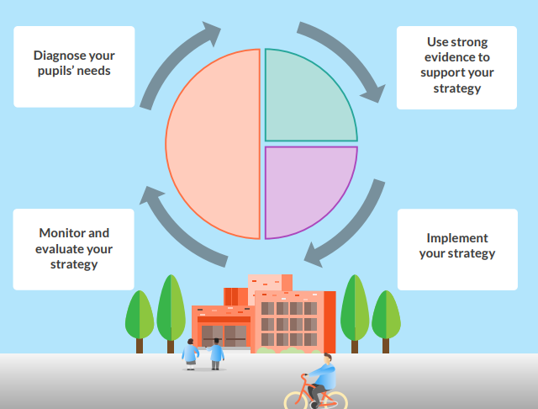
THE EEF GUIDE TO PUPIL PREMIUM

Legislation and guidance
This policy is based on the pupil premium allocations and conditions of grant guidance 2024 to 2025, published by the Education and Skills Funding Agency (ESFA). It is also based on guidance from the Department of Education (DfE) on virtual school heads’ responsibilities concerning the pupil premium and the service premium.

  - Use of the grant

Our spending strategy is informed by research evidence, referring to a range of sources, such as the guide published by the Education Endowment Foundation (EEF).

2. ELIGIBLE PUPILS
The pupil premium is allocated to the school based on the number of eligible pupils.
Eligible pupils fall into the categories explained below.
2.1 Ever 6 free school meals
Pupils recorded in the most recent October school census who are known to have been eligible for free school meals at any point in the last 6 years (as determined by the DfE’s latest conditions of grant guidance).
This includes pupils first known to be eligible for free school meals in the most recent October census.
This also includes pupils with no recourse to public funds (NRPF). The government has permanently extended FSM eligibility to include children in all households with NRPF.
It does not include pupils who received universal infant free school meals but would not have otherwise received free lunches.
2.2 Looked-after children (also known as Children in Care)
Pupils who are in the care of, or provided with accommodation by, a local authority (LA) in England or Wales for at least 1 day. Allocations will be provisionally based on the children looked-after data return in March of the previous year, and then confirmed in December of the current year based on the children looked-after data return in March of the current year.

Academies also receive the Pupil Premium Plus for every pupil who is currently in local authority care or who has left local authority care through adoption, a special guardianship order (SGO) or child arrangements order (formerly a Residence Order). . Local authorities get the same amount for each child they are looking after; they must work with the academy to decide how the money is used to support the child’s Personal Education Plan.
2.3 Post looked-after children
Pupils recorded in the most recent October census who were:
- Looked after by an English or Welsh local authority immediately before being adopted, or who left local authority care on a special guardianship order or child arrangements order
- In state care from outside England and Wales before being adopted

2.4 Ever 6 service children
Pupils recorded in the most recent October census:
- With a parent serving in the regular armed forces
- Who have been registered as a ‘service child’ in the school census at any point in the last 6 years (as determined by the DfE’s latest conditions of grant guidance), including those first recorded as such in the most recent October census
- In receipt of a child pension from the Ministry of Defence because one of their parents died while serving in the armed force

- OBJECTIVES

- The Pupil Premium will be used to provide additional educational support to improve the progress and to raise the standard of achievement for those pupils.

- The funding will be used to narrow and close the gap between the achievement of these pupils and their peers.

- As far as its powers allow the academy will use the additional funding to address any underlying inequalities between children eligible for the Pupil Premium and others.

- We will ensure that the additional funding reaches the pupils who need it most and that it makes a significant impact on their education and lives.

- Strategies

- Our culture believes in all pupils, seeking for all to achieve as well as possible from their starting points.

- Data will ensure the strengths and areas of development for each child will be a focus.

- Pupil Premium will be clearly identifiable within the budget.

- The Senior Leadership Team,will decide how the Pupil Premium is spent for the benefit of pupils.

- The Principal and Designated Teacher, in consultation with Virtual Schools and other relevant professionals involved, will decide how the Pupil Premium Plus is spent for the benefit of Looked After Children and previously Looked After Children.

- The academy will assess what additional provision should be made for the individual pupils based up their circumstances and individual needs.

- High quality teaching and learning including a consistent approach throughout school of specific PSHE-based activities will form the basis of improving the educational achievements of the pupils eligible for extra funding. All children will benefit from the consistency and familiarity provided.

- High expectations will be set, good practice will be shared and staff provided with ongoing CPD.

- Intervention and catch up work will seek to improve attendance, provide an enriched, active and healthy start to the day with sensory circuits, breakfast club and movement time outside to support sensory integration and readiness to learn.

- Additional support will be provided for pupils who may require additional agency work to provide specific interventions. This may include upskilling staff and providing equipment to support communication and developing independence.

- Pupils may also require support at times of personal or family need.

- Interventions identified as high impact such as those identified in the Education Endowment Foundation Teaching & Learning Toolkit (2018) will support decision making in our work.

- The academy will be accountable for how it has used the additional funding to support the achievement of those pupils covered by the Pupil Premium and the Principal will report to the governing body on how effective the intervention has been in achieving its aims.

- We will publish information on the Academy website about how we have used the pupil premium on a yearly basis.

- We will ensure that parents, governors and others are made fully aware of the attainment of pupils covered by the pupil premium.

- We will seek to further develop strategies and interventions which can improve the progress and attainment of these pupils.

- We will track the impact of the strategies put into place through the funding to ensure that we can show the value that has been added.

- We will regularly monitor, evaluate and review the success of the impact of the pupil premium funding using measurable targets and provide regular feedback to governors about this.

- PROVISION AND INTERVENTIONS

The academy will provide for pupils eligible for the pupil premium depending upon their individual need. Such provisions and interventions could for example, include any of the following:

- One-to-one sessions
- Small group work
- Communication and interaction
- Developing lifeskills/independence
- Social and emotional support
- Homework Club
- Attendance on educational academy trips and visits
- Additional support to enable full participation in learning

The Principal reserves the right to make the final decision on the applicability and suitability of any such provisions on the basis of educational need and pupil welfare.

- LINKS TO OTHER POLICIES AND DOCUMENTATION

This policy should be read in conjunction with:

- SEN Policy
- The Academy Website
- Pupil Premium Strategy document

- ROLES AND RESPONSIBILITIES

We expect all members of our academy community, particularly staff and governors to be committed to raising standards and narrowing the attainment gaps for our students.

  - The Senior Leadership Team

The Senior Leadership Team have responsibility for deciding how the Pupil Premium funding should be best spent and to monitor the effect that it has. This includes ensuring that it ‘diminishes the difference’ in attainment and ‘accelerates progress’.

The Senior Leadership Team will formulate a strategy statement on the use of Pupil Premium Funding which will be made available on the academy website and for the Academy governors.

Individual class teachers have responsibility for knowing which children have Pupil Premium funding, how this has been spent and the impact that it has on the child. The Pupil Premium Governor has responsibility for having knowledge and understanding of the way that Pupil Premium is used within the academy, including how decisions on the Pupil Premium are taken and how they are monitored

All staff are aware of their responsibilities in narrowing the gaps of our students. They will ensure that all staff are given appropriate support and relevant professional development opportunities to accelerate students’ progress and attainment. Through the Academy Development Plan, staff will make sure that narrowing the gap in progress and attainment between students in receipt of the pupil premium and other students is a priority area of focus for the academy.

It will be the responsibility of the Principal to report Pupil Premium information to Governors which will include:

- The progress made towards narrowing the gap for disadvantaged students

- An outline of the provision that has been made since the last annual report and he impact for socially disadvantaged pupils.

- An evaluation of the estimated costs and their effectiveness, in terms of the progress made by students receiving particular provisions.

6.2 Teaching and Support Staff will:

- Maintain the highest expectations of all students and not equate disadvantage of circumstance with ‘low ability’.
- Promote an inclusive and collaborative ethos in their classrooms which enable students from disadvantaged backgrounds to thrive.
- Plan and deliver the curriculum and lessons to a high standard and support the acceleration of progress in learning, so that gaps can be narrowed and improvements maintained.
- Support disadvantaged groups of students in their class through differentiated planning and teaching, especially for those who find aspects of learning difficult and are in danger of falling behind.
- Keep up-to-date with teaching strategies and research, which have a proven track record in narrowing the gaps in attainment and achievement.

The academy will provide opportunities for staff to engage in a range of professional development opportunities suited to their particular needs and role. This will support them in implementing successful strategies to accelerate progress of students and narrowing the gaps.

  - The Governing Body

Our governing body has an important role in ensuring our academy complies with legislation and that this policy, along with its specific stated actions for narrowing the gaps is implemented.

Our governing body will keep our work in narrowing the gaps under review so that they can monitor the use of the pupil premium. In monitoring and evaluating the work of the academy in relation to the pupil premium, the governing body will take into account a range of information, including quantitative (data on progress and attainment) and qualitative (case studies, views, surveys etc.) data as evidence of impact.

6.4 Virtual School Heads

The Virtual School (a multi-agency team consisting of a virtual head teacher, assistant head, Fostering Education Liaison Officers (FELOs), Education Support Officers, Progression Advisors, Support Officers and Education Welfare Officers) provides advice and information to schools on how to make the best use of the grant.

Virtual school heads are responsible for managing pupil premium funding for children looked after by a local authority, and allocating it to schools. Their responsibilities include, but are not limited to:

- Identifying the eligible looked after children and informing the local authority
- Making sure methods for allocating and spending ensure that looked after children benefit without delay
- Working with each looked after child’s educational setting to put together a personal education plan, agree how pupil premium funding will be spent to the meet the need identified in this plan, and ensure the funding is spent in this way
- Demonstrating how pupil premium funding is raising the achievement of looked after children
Virtual school heads are in charge of promoting the educational achievement of all the children looked after by the local authority they work for.

- MONITORING

- Pupils will be supported through:
- Analysis of data
- Reviewing their work
- Carrying out learning walks and snapshots
- Gaining the views of pupils, parents and staff
- Termly assessment data is used to collect information progress.
- Data is shared by staff and moderated
- Parent/carers receive feedback three times per year
- The designated Pupil Premium Champion is Miss Saywell, who supports the pupil premium and funding.
- The named Governor for Pupil Premium is Ms Stanton

- OUTCOMES

This policy will make an important contribution to the educational development of the individual pupils who are entitled to the pupil premium. We will ensure that these pupils are treated equally and as favourably as others and that the educational funding is used well to address the challenges they face. The academy will use the additional funding to promote the achievement and progress of all entitled pupils.

Through wise and effective use of this additional funding we are fully committed to ensuring that the individual needs of each entitled child are met. As a result of the additional funding we will strive to ensure that these children make the best possible progress and achieve the highest possible standards.

- PUPIL PREMIUM STRATEGY

We will publish our pupil premium strategy statement on the Academy’s use of the pupil premium in each academic year on the academy website, in line with the DfE’s guidance on using the pupil premium and using the template from GOV.UK.
This policy includes recommendations from Ofsted on best practice in the use of the pupil premium within schools and academies.

This policy will be reviewed annually.
Next review: September 2025

https://www.gov.uk/government/publications/pupil-premium-allocations-and-conditions-of-grant-2024-to-2025/pupil-premium-2024-to-2025-conditions-of-grant-for-academies-and-free-schools

https://www.gov.uk/guidance/pupil-premium-virtual-school-heads-responsibilities

https://d2tic4wvo1iusb.cloudfront.net/production/documents/guidance-for-teachers/pupil-premium/Pupil_Premium_menu_evidence_brief.pdf.pdf?v=1649431092

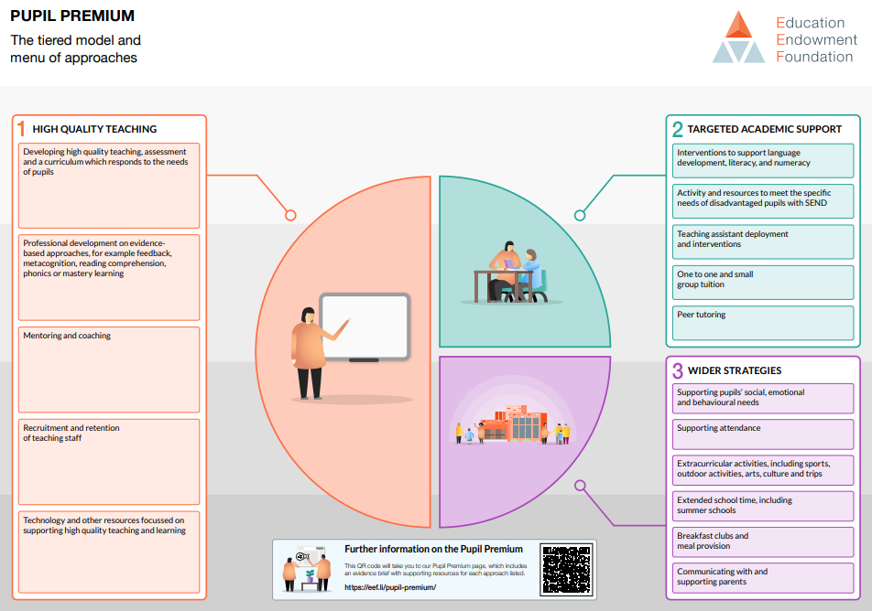

See The Education Endowment Foundation Teaching & Learning Toolkit (2018) available at www.educationendowmentfoundation.org.uk.

