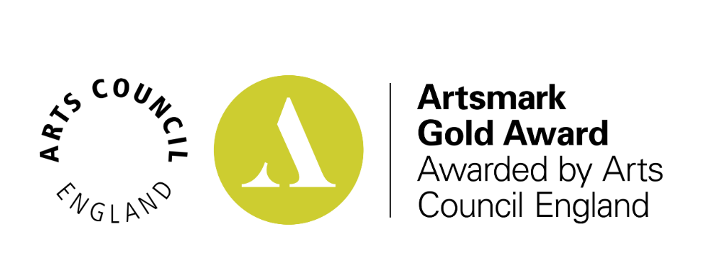
Gosberton House Academy
Thank you for your recent submission, and congratulations on completing your Artsmark journey.
You've achieved an Artsmark Gold Award!
We are delighted to inform you that your setting has been awarded an Artsmark Gold Award. Congratulations!
Your Statement of Commitment and Statement of Impact have been assessed and we’re pleased to share this feedback from our assessors with you:
'Gosberton House Academy have used this Artsmark journey to develop the amount and range of everyday arts activities that your pupils take part in. You have embedded arts in the formal and informal curriculum, putting arts at the centre of your provision. The whole staff team have discussed Artsmark and the role of the Arts in the development and enhancement of topics. Staff now see the Arts as stand-alone subjects and tools to support engagement throughout the curriculum. You have developed your staff team’s skills including in house training and external CPD from Charanga and created Story Sacks including sensory and singing themes that are used across a wide range of subjects and art forms. You have shared your practice with professionals and families, and you use external agencies to teach music. You have seen an improvement in your pupil’s readiness to learn as a result of these activities. You have started to develop pupil agency with pupils instigating a guitar club and you responded to their views when restarting choir. Are there ways you could develop the voice and influence of all children and young people, so they contribute actively to the planning and delivery of authentic arts, cultural and creative experiences? Have you considered how Arts Award could support developing the voice and agency of your pupils? To develop further could you consider how your arts and cultural provision is representative of the diversity of your setting as well as wider society? Could you collaborate with local artists and arts organisations when planning and delivering your curriculum or on staff training, and develop the cultural community by linking to local creative practitioners and organisations? In all these areas you should consider how you will measure the impact of activity on outcomes for pupils and staff.'
Congratulations on your Artsmark Gold Award!
Your award is valid for two years and will expire on 15/08/2025

