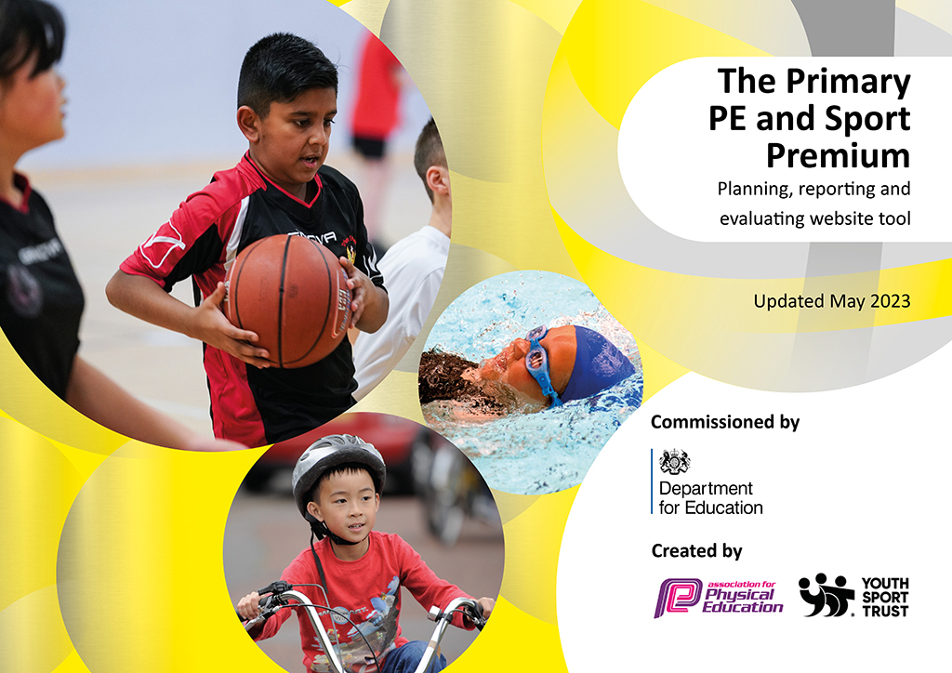
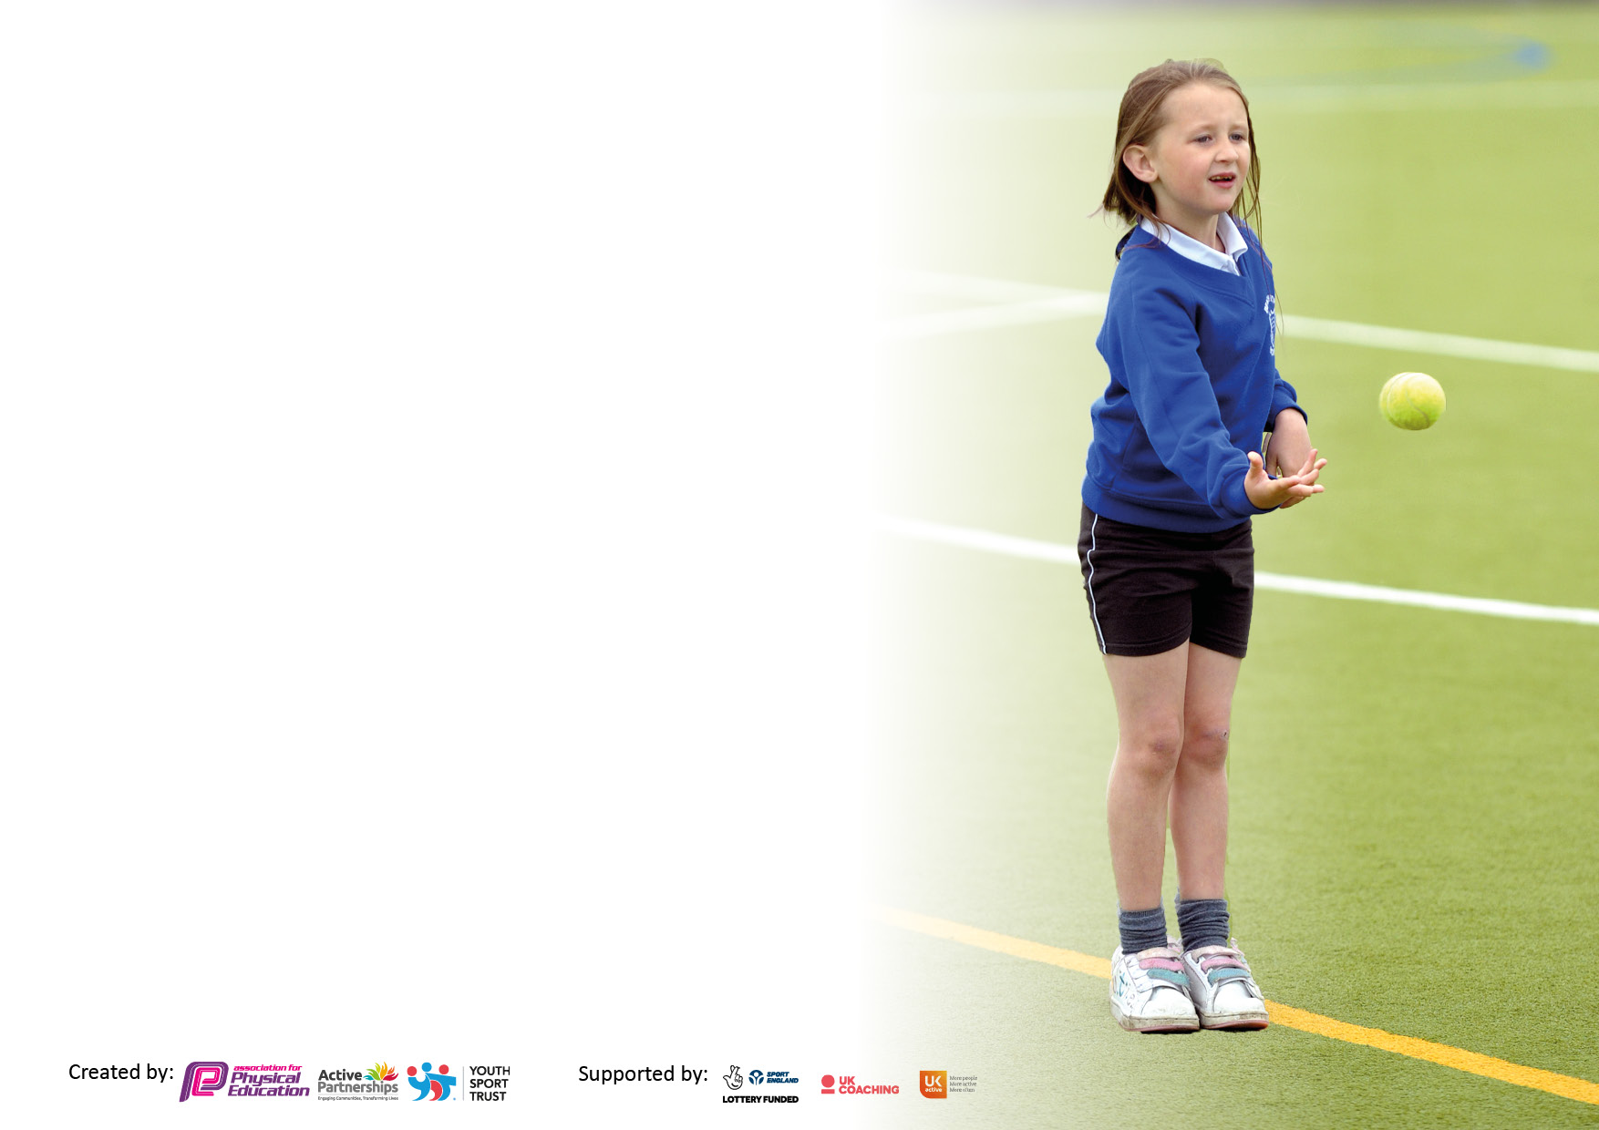

It is important that your grant is used effectively and based on school need. The Education Inspection Framework makes clear there will be a focus on ‘whether leaders and those responsible for governors all understand their respective roles and perform these in a way that enhances the effectiveness of the school’.

Under the Quality of Education judgement, Ofsted inspectors consider:
Intent - Curriculum design, coverage and appropriateness
Implementation - Curriculum delivery, teaching (pedagogy) and assessment
Impact - Attainment and progress

To assist schools with common transferable language, this template has been developed to utilise the same three headings which should make your plans easily transferable between working documents.

Schools must use the funding to make additional and sustainable improvements to the quality of Physical Education, School Sport and Physical Activity (PESSPA) they offer. This means that you should use the Primary PE and sport premium to:

- Develop or add to the PESSPA activities that your school already offers
- Build capacity and capability within the school to ensure that improvements made now will benefit pupils joining the school in future years
- The Primary PE and sport premium should not be used to fund capital spend projects; the school’s budget should fund these.

Please visit https://www.gov.uk/guidance/pe-and-sport-premium-for-primary-schools for the revised DfE guidance, including the 5 key indicators across which schools should demonstrate an improvement. This document will help you to review your provision and to report your spend. DfE encourages schools to use this template as an effective way of meeting the reporting requirements of the Primary PE and Sport Premium.

We recommend you start by reflecting on the impact of current provision and reviewing the previous spend.

Schools are required to publish details of how they spend this funding, including any underspend from 2021/2022, as well as on the impact it has on pupils’ PE and sport participation and attainment.

We recommend regularly updating the table and publishing it on your website throughout the year. This evidences your ongoing self-evaluation of how you are using the funding to secure maximum, sustainable impact. Final copy must be posted on your website by the end of the academic year and no later than the 31 July 2023.

Details with regard to funding
Please complete the table below.

Total amount carried over from 2022/23 | £0
Total amount allocated for 2023/24 | £ same
How much (if any) do you intend to carry over from this total fund into 2024/25? | £0
Total amount allocated for 2023/24 | £same
Total amount of funding for 2023/24 to be reported on by 31st July 2024 | £ same
Swimming Data
Please report on your Swimming Data below.

Meeting national curriculum requirements for swimming and water safety.

N.B. Complete this section as best you can. For example, you might have practised safe self-rescue techniques on dry land which you can then transfer to the pool when school swimming restarts.
Due to exceptional circumstances priority should be given to ensuring that pupils can perform safe self-rescue even if they do not fully meet the first two requirements of the NC programme of study
What percentage of your current Year 6 cohort swim competently, confidently and proficiently over a distance of at least 25 metres?  N.B. Even though your pupils may swim in another year, please report on their attainment on leaving primary school at the end of the summer term 2023.  Please see note above | %
What percentage of your current Year 6 cohort use a range of strokes effectively [for example, front crawl, backstroke and breaststroke]?  Please see note above | %
What percentage of your current Year 6 cohort perform safe self-rescue in different water-based situations? | %
Schools can choose to use the Primary PE and sport premium to provide additional provision for swimming, but this must be for activity over and above the national curriculum requirements. Have you used it in this way? | Yes/No

Action Plan and Budget Tracking
Capture your intended annual spend against the 5 key indicators. Clarify the success criteria and evidence of impact that you intend to measure to evaluate for pupils today and for the future.

Academic Year: 2022/23 | Total fund allocated: | Date Updated:
Key indicator 1: Increase confidence, knowledge and skills of all staff in teaching PE and sport |  |  |  | Percentage of total allocation:
 |  |  |  | %
Intent | Implementation |  | Impact
Your school focus should be clear on what you want the pupils to know and be able to do. What do they need to learn and to consolidate through practice: | Make sure your actions to achieve are linked to your intentions: | Funding allocated: | Evidence of impact:  What do pupils now know and what can they now do? What has changed? | Sustainability and suggested next steps:
Improve the quality of PE at GHA through up skilling staff.  - Teacher with PE specialism is up skilling his own knowledge and understanding. For example completing the Sainsburys inclusive for all course  - Delivering a broad and consistent approach to PE across the school.  - Address health and safety in PE across the school.  - Identify outside support to offer expertise to enhance learning and creating memorable experiences.  - Continue with AfPE to ensure access to specialist and expert support keeping the school regularly up to date as well as school competitions.  - To keep abreast of current local and SEN developments  - To introduce new strategies to increase engagement with PE lessons.  AFPE Quality mark shows the work done by GHA. | - Establish new ideas within PE lesson to engage the children – Attention Autism and story sacks.  - Research the First Move program and adapt for our learners to aid them to progress their core skills.  - Confidently disseminate to all staff, thus increasing their knowledge and confidence.  - Staff with knowledge upskilling and supporting staff in delivery of PE. A balanced/thematic approach is consistently delivered from EYFS to KS2.  - Complete Educare Courses relating Child safeguarding in PE and carry out regular inspections of equipment where necessary. Additional CPD/Opportunities to further enhance.  - Organise trips, visits, organisations coming into GHA.  - AFPE resources, membership used. Read magazines of latest news.  - Continue to visit other provisions and schools and look at PE in all needs. | £
Key indicator 2: The engagement of all pupils in regular physical activity – Chief Medical Officers’ guidelines recommend that  primary school pupils undertake at least 30 minutes of physical activity a day in school |  |  |  | Percentage of total allocation:
 |  |  |  | %
Intent | Implementation |  | Impact
Your school focus should be clear on what you want the pupils to know and be able to do. What do they need to learn and to consolidate through practice: | Make sure your actions to achieve are linked to your intentions: | Funding allocated: | Evidence of impact:  What do pupils now know and what can they now do? What has changed? | Sustainability and suggested next steps:
- Ensure that all pupils receive a good start to the day.  - Enable all pupils to be more active before learning and during learning.  - Enable pupils to have a more active playtime and a more active experience throughout the school day.  - To enable more children to engage with PE lessons and skills. | - Review breakfast club provision, before school and healthy snacks within school; alongside the before school playtime provision.  - Ensure children have the sensory integration and movement breaks they need.  - Ensure sensory circuits is delivered correctly and targets the correct children.  - Make sure all children access ‘Activate’ in the classroom which is suitable for their needs.  - Review playtime equipment, how can we make it more engaging and suitable for the children’s needs?  - Promote Active learning ideas throughout the curriculum, establish links to topic based learning.  - Start a lunchtime club(s).  - Create a timetable for different areas, to make sure they are being used effectively and throughout school.  - Establish new ideas within PE lesson to engage the children – Attention Autism and story sacks.  - Follow the First Move program to progress core skills for all. | £

Key indicator 3: The profile of PE and sport is raised across the school as a tool for whole school improvement |  |  |  | Percentage of total allocation:
 |  |  |  | %
Intent | Implementation |  | Impact
Your school focus should be clear on what you want the pupils to know and be able to do. What do they need to learn and to consolidate through practice: | Make sure your actions to achieve are linked to your intentions: | Funding allocated: | Evidence of impact:  What do pupils now know and what can they now do? What has  changed? | Sustainability and suggested next steps:
- Increase the profile of PE through rewards for all pupils and the profile of PE.  In order to develop children for the 21st Century, GHA will: -  - Through PSHE and Healthy Schools Award - Pupils are aware of the link between exercise, diet and healthy lifestyles.  - Continue to develop an ‘inclusive’ approach to PE, Sport and Games  - Equip pupils with the tools to develop social skills to participate in a variety of sport, PE and games and general enjoyment of leisure activities.  PE tagline ‘Adaptive for all’ – create opportunities for all. | - Establish regular provision of Sport related rewards through clubs’, Children’s University, bikeability, recognised schemes. Provision of PE stickers and happy notes and reach out to engage families/ carers. Also wow afternoons to ensure profile is being exposed.  - On PE display board. In PE lessons. Language used from staff.  - Continue to demonstrate our commitment to healthy lifestyles through PSHE, Cooking, Forest School, Scouting and Physical day to day activities across the school in lessons and clubs.  - Develop lesson plans that demonstrate the ‘inclusive’ nature of PE lessons and the emphasis upon participation, challenge and competition. Develop the whole child in lessons.  - Overview theme planning and cycles – to ensure that pupils have access to a broad and balanced, sequentially planned curriculum. So that pupils can develop their knowledge, skills and attitude to learning. | £
Key indicator 4: Broader experience of a range of sports and physical activities offered to all pupils |  |  |  | Percentage of total allocation:
Intent | Implementation |  | Impact
Your school focus should be clear on what you want the pupils to know and be able to do. What do they need to learn and to consolidate through practice: | Make sure your actions to achieve are linked to your intentions: | Funding allocated: | Evidence of impact:  What do pupils now know and what can they now do? What has  changed? | Sustainability and suggested next steps:
- Introduce and offer a wide range of sporting experiences to all our families.  - Increase levels of activity and fitness.  - Purchase of new equipment., Provides new opportunities and broaden experience and engagement.  - Through global awareness pupils experience the range of sports that is accessible. | - Will do pupil voice to see what direction and experiences they would like and try to implement.  - Form links with other SEND schools to provide inter sport competition and experience their provision/resources.  - Form links with external agencies/organisations. For example local swimming and tennis clubs.  - Promote external opportunities and clubs on our schools website.  - Invite external visitors into school to showcase their sport – ice hockey, football etc.  - Increase awareness of Global events during assemblies and Children’s university. For example National Drowning week and Paralympics.  - Lunchtime club to be set up to increase opportunities. | £

Key indicator 5: Increased participation in competitive sport |  |  |  | Percentage of total allocation:
 |  |  |  | %
Intent | Implementation |  | Impact
Your school focus should be clear on what you want the pupils to know and be able to do. What do they need to learn and to consolidate through practice: | Make sure your actions to achieve are linked to your intentions: | Funding allocated: | Evidence of impact:  What do pupils now know and what can they now do? What has  changed? | Sustainability and suggested next steps:
- School Games Award – reapply for award.  - Planning demonstrates challenges and opportunities for competitive games  - PE for all – opportunities provided/inclusive  - Teams take part in level 2 competitions and festivals | - Increasing engagement, Developing opportunities. Broadening range of opportunities, Increased and sustained participation to ensure school games criteria is met.  - Establishing links between with local SEND schools that will create greater opportunities for competitions e.g. games afternoons, opportunities to visit another facility.  - Opportunity for all pupils to engage in some form of competitiveness, to expose them to the nature of the participation in sport.  - Entering more competitions to increase participation in competitive sport.  - Special paralmpic/Olympic challenge set up within school, to expose children to competition. | £

Signed off by
Head Teacher: | K Saywell
Date: | May 2023
Subject Leader: | Rhian Worley
Date: | May 2023
Governor: | Louise Stanton
Date: | May 2023

